GIT ASSIGNMENT

1)git config –global --list

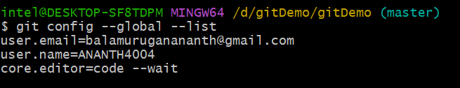

2) ls -al

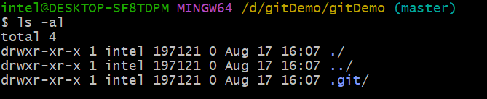

3)echo "Hi i am Anand">> hello.txt

Ls -al

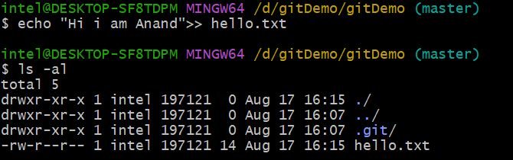

4)cat hello.txt

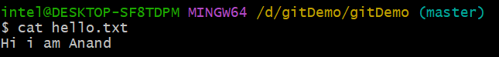

5) git status

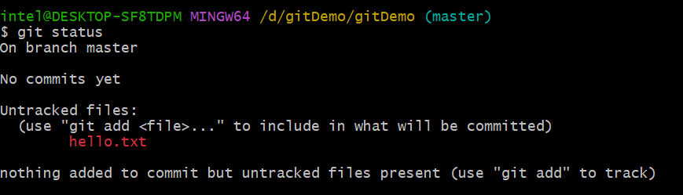

6) git add .



7) git commit -m "first commit"

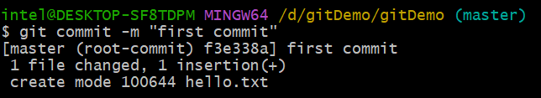

8) git remote add origin <https://ANANTH4004/gitDemo.git>

git remote set-url origin <https://github.com/ANANTH4004/gitDemo.git>

git push origin master

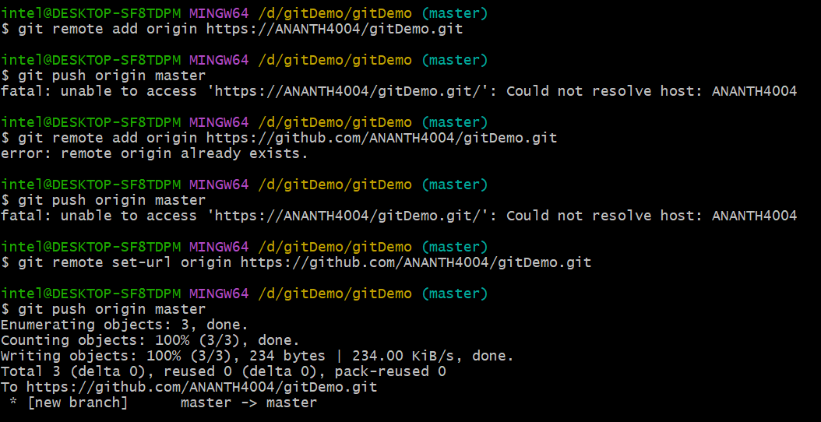

================================================================

1. touch .gitignore => cat .gitignore => git add . => git status

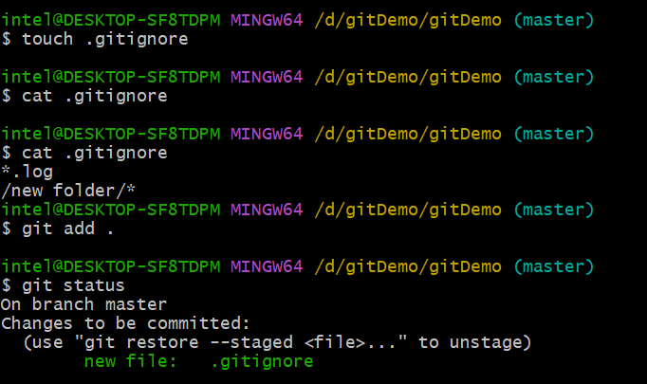

2) git add . => it won’t add .log files but add .txt files

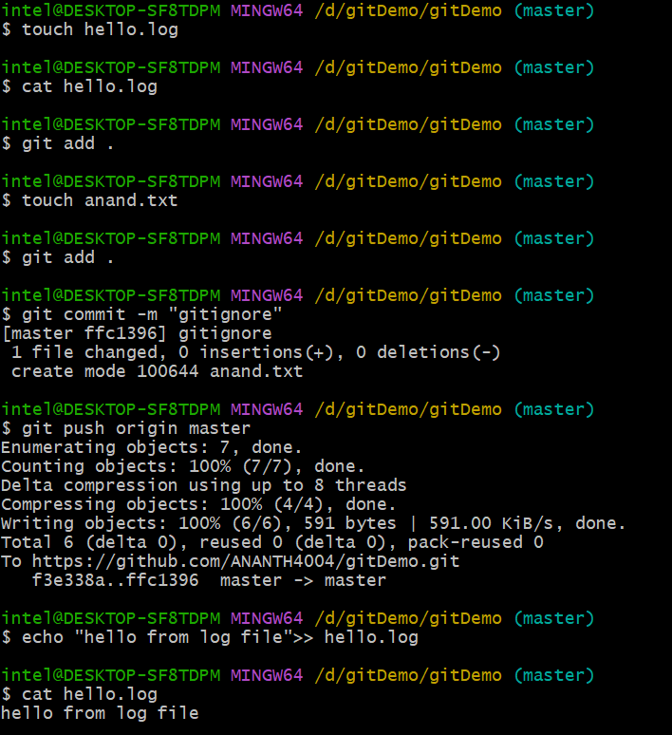

================================================================

1) git branch gitNewBranch.

2) git branch .

3) git checkout gitNewBranch.

4) touch gitnew.txt = > git add . => git commit –m “commit from new branch”.

5) git status.

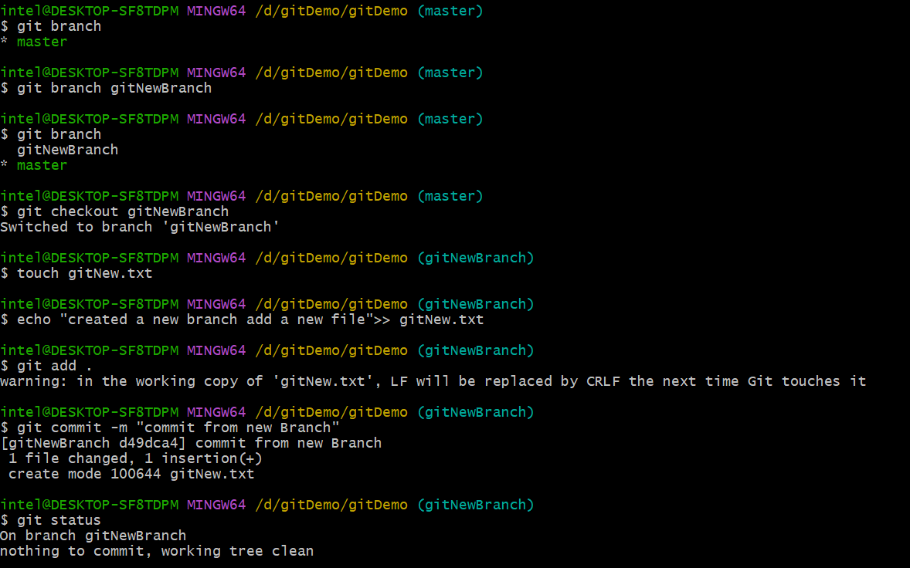

Merging:

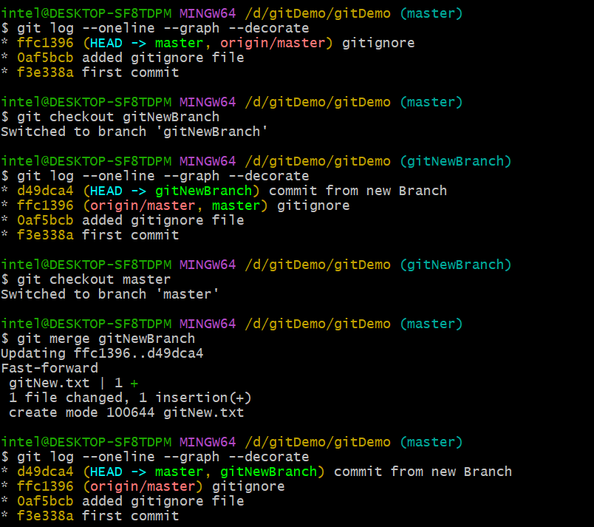

Delete a Branch:

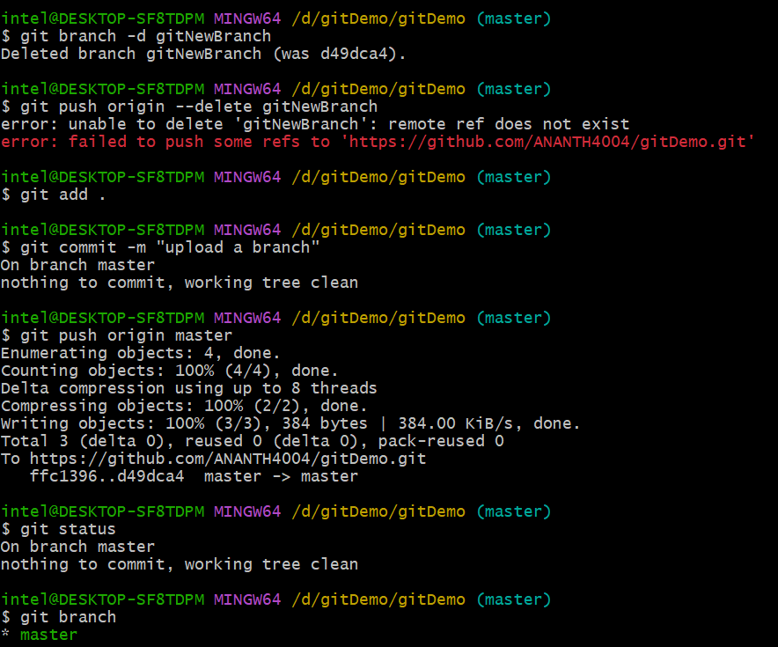

================================================================

1) git status

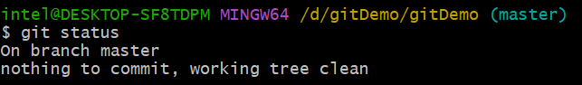

2) git branch gitWork

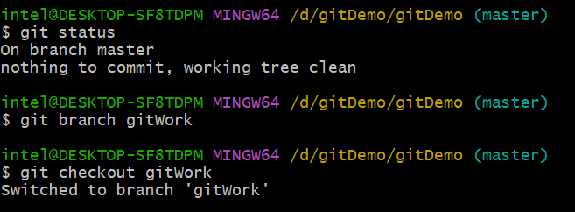

3) touch hello.xml

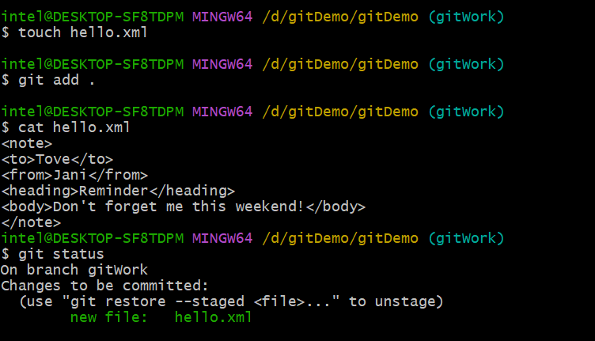

4) git commit

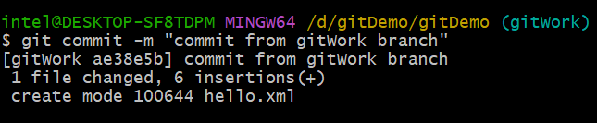

5,6,7) 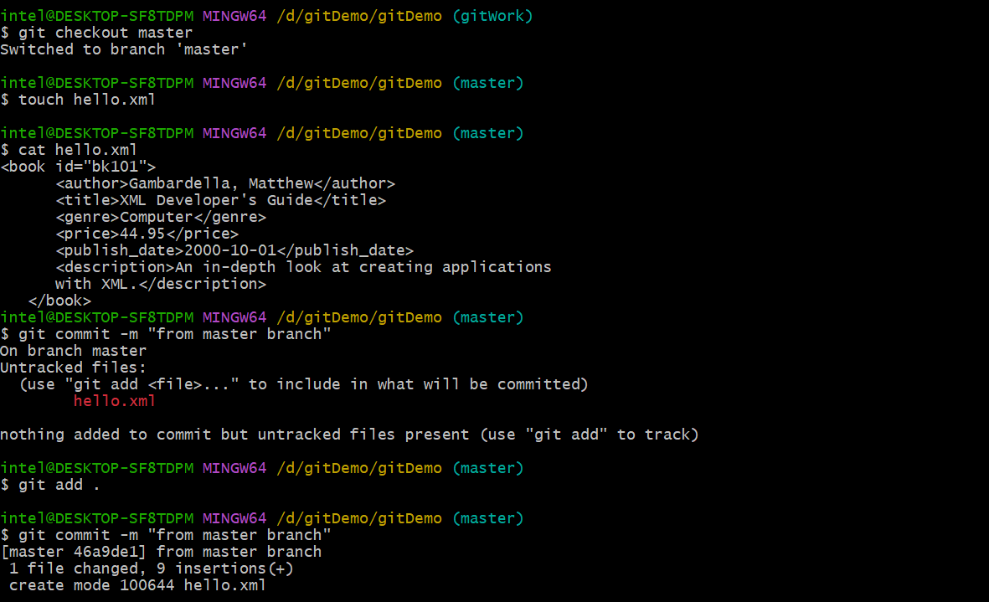

8) git log –oneline –graph –decorate –all

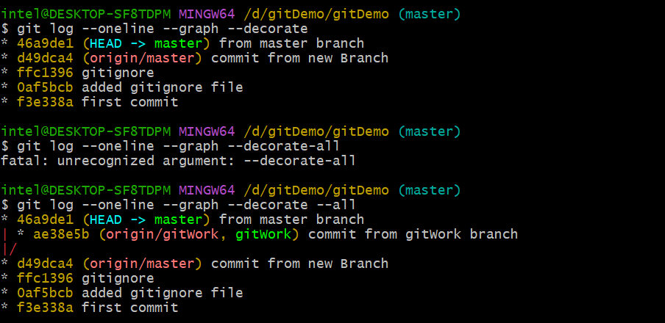

9) git diff gitWork..master – hello.xml

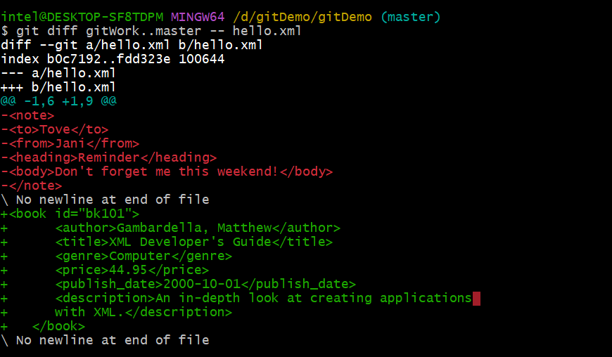

Assignment 5:

